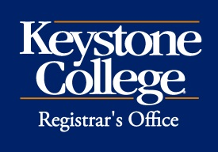 Intent to Pursue Prior Learning Assessment (PLA)
Prior Learning Assessment (PLA) is an assessment of previous work, training, and life experiences that allows students to earn credit toward degree completion by demonstrating relevant college-level knowledge.

Once ready to pursue Prior Learning Assessment, complete this form and pay the associated fee of $125. Once received, the student will be connected with the Career Services Success Coach and enrolled in the PLA Workshop in Moodle. Students will utilize the PLA Workshop and work with the Career Services Success Coach to prepare assessment materials, including an ePortfolio, resume, supporting documents or evidence, and a statement of achieved learning outcomes.

Name: ID:

Identify all courses for which PLA evaluation is requested. Only the courses identified will be evaluated.

Course Number: Course Title: Number of Credits:

Create a submission timeline for all assessment materials. This will be used by the Office of Retention and Student Success and Career Services to ensure students are on track for PLA evaluation. Please note students have 6-8 weeks to submit an ePortfolio for review.

PLA credit is awarded based on an evaluation of competencies and learning outcomes aligned with traditional course content. If PLA evaluation meets the course learning outcomes and is approved for credit, the student will be automatically charged $100 per approved credit. Courses for which PLA credit is requested are not included in the calculation for full-time status and do not qualify for financial aid.

Student Signature: Date:

Academic Advisor: Date:

