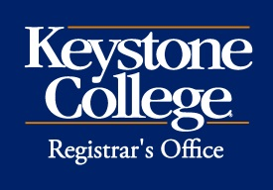 Alumni Discount for Graduate Programs
Alumni of Keystone College who are enrolled as matriculating students in a Master’s degree program are eligible to receive a 10% tuition discount. Complete and submit this form to the Registrar’s Office for processing. This discount will only apply to current and future terms, it is not able to be applied retroactively.

Name: ID:

Address:

City, State, Zip:

Phone: Mobile:

Degree earned: ⧠ Bachelor’s degree ⧠ Associate degree
Date earned:
Current Master’s Program:
Anticipated graduation date:
I understand that I may not use this discount in combination with any other discount or tuition reduction.

Student Signature: Date:

FOR OFFICE USE ONLY

Date Received Initials Date Processed ^{Rev. 12/15}

