2021‐2022 STANDARD/HOUSEHOLDRESOURCES VERIFICATION WORKSHEET (V1)
Your 2021–2022 Free Application for Federal Student Aid (FAFSA) was selected for review in a process called verification. The law says that before awarding Federal Student Aid, we may ask you to confirm the information you and/or your parents reported on your FAFSA. The financial aid administrator at your school will compare your FAFSA with the information on this worksheet and any other required documents. If there are differences, your FAFSA information may need to be corrected. Your school may ask for additional information. If you have questions about verification, contact your financial aid administrator as soon as possible so that your financial aid will not be delayed.
Warning: This form will be rejected if it is incomplete or illegible…please complete carefully!

STEP 1 – STUDENT INFORMATION

Last Name | First Name | Social Security Number | Student ID
Permanent Address | Street & Number | City/State/Zip
Home Phone | Cell Phone | Email Address

STEP 2 – FAMILY INFORMATION: check one of the following/supply information accordingly
Independent Students: List the people in your household:
- Yourself and your spouse, if married
- Your children, if you provide more than half of their support from July 1, 2021 through June 30, 2022
- Any other people if they now live with you and you provided more than half of their support and will continue to provide more than half of their support from July 1, 2021 through June 30, 2022.

Dependent Students: List the people in your parents’ household:
- Yourself, your parent(s) you live with (include stepparent), must include both of dependent student’s legal (biological and adoptive) parents if they live together regardless of marital status or gender.
- Your parents’ other children if your parent(s) will provide more than half of their support from July 1, 2021 through June 30, 2022, or if the other children would be required to provide parental information if they were completing a FAFSA for 2021-2022. Include children who meet either of these standards, even if they do not live with your parent(s).
- Any other people if they now live with your parents and your parents provided more than half of their support and will continue to provide more than half of their support from July 1, 2021 through June 30, 2022.
PLEASE LIST ALL HOUSEHOLD MEMBERS BELOW.
Number in College: Include in the space below information about any household member who is, or will be, enrolled at least half time in a degree, diploma, or certificate program at an eligible postsecondary educational institution any time between July 1, 2021, and June 30, 2022, and include the name of the college.

Full Name | Age | Relationship to student | Name of College or University (if at least ½ time 2021-2022)
Joshua Jones (EXAMPLE) | 24 | Self | Example University

STEP 3 – STUDENT OR STUDENT/SPOUSE (FILING JOINT) FILING INFORMATION
201

Please check one box below that applies to the student or student and spouse (if filing joint):

The student HAS used the data retrieval tool on the FAFSA. The IRS data retrieval tool allows students to transfer their income information from the IRS directly to the FAFSA. If the student used this tool, they will NOT need to submit 2019 IRS tax return transcripts.
The student is unable or chooses not to use the IRS Data Retrieval Tool on the FAFSA, the student will submit a 2019 Form 1040 SIGNED or a 2019 IRS tax return transcript, instructions attached.
The student was unemployed and had no income earned from work in 2019 and student will submit a
“Verification of Non-Filing” (requests not issued until after June 15, 2019), instructions attached.
***verification of non-filing is NOT required for dependent students***
The student was employed in 2019 and did not file a tax return. Please list below the names of all the student’s employers, the amount earned from each employer in 2019.

-W-2 is required if you check this box and student must submit a “Verification of Non-Filing,
Instructions attached.
***verification of non-filing is NOT required for dependent students***

STEP 4 – PARENT OR SPOUSE (FILING SEPARATE) FILING INFORMATION
201
Employer’s Name | 2019 Amount Earned
Suzy’s Auto Body Shop (example) | $2,000.00(example)

Please check one box below that applies to parent(s) or spouse (if filing separately):

The parent(s)/spouse HAVE used the data retrieval tool on the FAFSA. The IRS data retrieval tool allows parent(s)/spouse to transfer their income information from the IRS directly to the FAFSA. If a parent(s)/spouse used this tool they will NOT need to submit tax transcripts.
The parent(s)/spouse is unable or chooses not to use the IRS Data Retrieval Tool on the FAFSA, the parent(s)/spouse will submit a 2019 Form 1040 SIGNED or a copy of the parent(s)/spouse 2019 IRS tax return transcript(s), instructions attached.
The parent(s)/spouse were unemployed and had no income earned from work in 2019 and will submit a
“Verification of Non-Filing”, (requests not issued until after June 15, 2019), instructions attached.
The parent(s)/ spouse were employed in 2019 and did not file a tax return. Please list below the names of all the parent’s/ spouse employers, the amount earned from each employer in 2019.
Employer’s Name | 2019 Amount Earned
Suzy’s Auto Body Shop (example) | $2,000.00 (example)
-W-2 is required, if you check this box and parent or spouse must submit a “Verification of Non-Filing”, instructions attached

STEP 5 – UNTAXED INCOME INFORMATION‐ do not leave any questions blank.

Do not leave any questions blank. If not applicable, please put 0”.  Answer all questions by filling in correct amounts for 2019 | Student/Spouse | Parent(s)
Child support received for all of your children. Don’t include foster care or adoption payments. | $ /YEAR | $ /YEAR
Other untaxed income not reported on the previous questions or accounted for in tax return workers’ compensation disability  social security tax deferred pension/savings other_ | $ /YEAR | $ /YEAR
Veterans non‐educational benefits/ Military or Clergy allowances | $ /YEAR | $ /YEAR
Money received, or paid on your behalf (e.g., bills), not reported elsewhere on this form. | $ /YEAR | $ /YEAR

STEP 6 – CERTIFICATION AND SIGNATURES
Each person signing this worksheet certifies that all of the information reported on it is complete and correct.

Student’s Signature Date

Parent’s Signature Date

*Please make a copy for your records
W ARNING: If you purposely give false or misleading information on this worksheet, you may be fined, be sentenced to jail, or both.

Submit this worksheet to:
Keystone College Student Central Att. Financial Aid One College Green LA Plume, PA 18440
Phone: 570‐945‐8300 FAX: 570‐945‐8967
Email: financialaid@keystone.edu Please make a copy for your records.

Instructions on Requesting Tax Information

You will need your Social Security Number, date of birth, a valid email address, and the address on file with the IRS (normally this will be the address used when your 2019 IRS tax return was filed). It takes up to two weeks for IRS income information to be available for electronic IRS tax return filers, and up to eight weeks for paper IRS tax return filers. If you are married and you and your spouse filed separate 2019 tax returns, you must submit tax return transcripts for both you and your spouse.

Go to www.irs.gov

- Under tools, select GET YOUR TAX RECORD

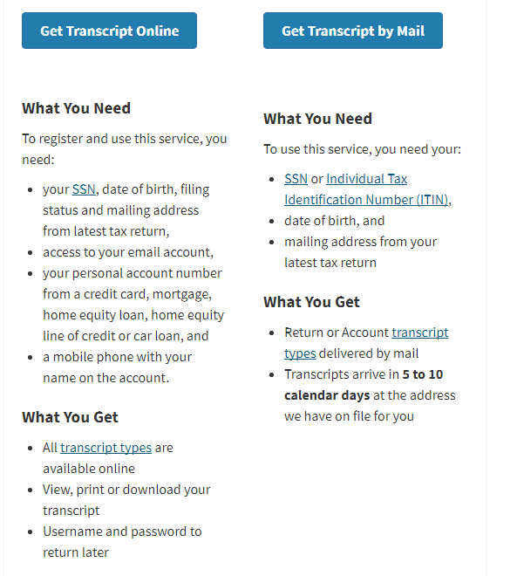

Requesting Documents for Amended Tax Returns

If you or your parent(s)/spouse have filed an amended IRS tax return you are required to provide the documents below to complete verification.

  - A copy of the 2019 IRS Tax Return Transcript (per above instructions), or any IRS tax transcript that includes all of the income and tax information required to be verified, and
  - A signed copy of the 2019 IRS Form 1040X that was filed with the IRS.

Request for Verification of Non-Filing Letter

Non-tax filers must request a Verification of Non-Filing Letter from the Internal Revenue Service (IRS), free of charge. You can only request via mail. Please note that current year requests are only available after June 15th.

Paper Request
- Download the IRS Form 4506T at http://www.irs.gov/pub/irs-pdf/f4506t.pdf.
- Print form off and complete lines 1-4. On line 7, check the box to indicate you would like to receive a Verification of Non-Filing, proof that you did not file a return for the year

On line 9 indicate the ending date on the year or period. For 21-22 verification the date should be 12/31/2019.
- Mail or fax the form to the correct location based on where you live. Use 2nd Page of 45067T to determine this address or fax number.

The Verification Letter of Non-Filing will be mailed to you within 10 business days.

Submit this worksheet to:
Keystone College Student Central Att. Financial Aid One College Green LA Plume, PA 18440
Phone: 570-945-8300 FAX: 570-945-8967
Email: financialaid@keystone.edu Please make a copy for your records.

