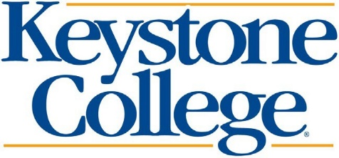
Citizenship Confirmation

Student’s Last Name Student’s First Name Student’s M.I. Student’s ID Number Student’s Street Address (include apt. no.) Student’s Date of Birth
City State Zip Code Student’s Email Address

Student’s Home Phone Number (include area code) Student’s Alternate or Cell Phone Number

Based on the information reported on your Free Application for Federal Student Aid (FAFSA), the Bureau of Citizenship and Immigration Services, (BCIS) was unable to confirm your citizenship or eligible non-citizen status. Please provide any of the documents below to confirm your citizenship or eligible non-citizen status. All documents must be SIGNED, clear, legible and presented in person. If you are unable to present these documents in person, please attach the CERTIFICATION OF TRUE, EXACT, AND COMPLETE COPY OF ORIGINAL DOCUMENT FORM.
Citizen Born in the United States
- US Passport  - Copy of Birth Certificate | Document must be SIGNED by the student
Citizen Not Born in the United States | If you have not already done so, please go to your local Social Security Administration office to update your citizenship status.
- Certification of Citizenship  - Certificate of Naturalization  - Certification of Birth Abroad (FS-545, DS-1350, or FS-240)  - US Passport | Must have student’s name, certificate number, and the date issued with the student’s name, certificate number, Alien Registration number, name of the court, and date where naturalization occurred. Must have embossed seal “United States of America” and “State Department”.  Must be signed by the student.
Permanent Resident
- Permanent Resident Card (Form I-551)  - Alien Registration Receipt Card  - Foreign Passport  - I-92 Card or I-94A Card | Must be stamped “Processed for I-551” with expiration date.  Must be stamped “Processed for I-551” with expiration date.  Must be stamped “Processed for I-551” with expiration date or Temporary Form I-551 with appropriate information.
Other Eligible Citizen
- US Passport  - Arrival Departure Record | Must be stamped “Noncitizen National”  Must be stamped as one of the following: Refugee Asylum Status, Conditional Entrant (before April 1, 1980), Parolee, Cuban Haitian Entrant.
By signing this form, I certify all information reported on this form and within the enclosed documentation is complete and correct. I understand that providing false or misleading information may result in a $20,000 fine, a prison sentence or both, according to the Higher Education Act of 1965, as amended, Section 490(a). Any false or misleading information is subject to cancellation of all Federal financial assistance.

Student Signature Date
Submit This Form & Documentation To: Keystone College Student Central Att: Financial Aid
One College Green LA Plume, PA 18440 Phone: 570-945-8300 Fax: 570-945-8967
Email: financialaid@keystone.edu
Please make a copy for your records.

