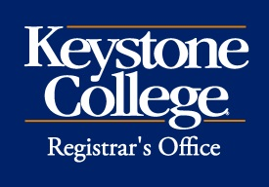 Alumni Discount for Graduate Programs
Alumni of Keystone College who are enrolled as matriculating students in a Master’s degree program are eligible to receive a 10% tuition discount. Complete and submit this form to the Registrar’s Office for processing

Name: ID:

Address:

City, State, Zip:

Phone: Mobile:

Degree earned: ⧠ Bachelor’s degree ⧠ Associate degree
Date earned:
Current Master’s Program:
Anticipated graduation date:
I understand that I may not use this discount in combination with any other discount or tuition reduction.

Student Signature: Date:

FOR OFFICE USE ONLY

Date Received Initials Date Processed ^{Rev. 12/15}

