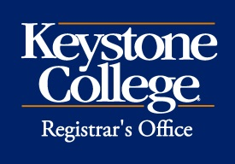 Credit by Assessment (P/F) Request
Courses taken through credit by assessment/exam are Pass/Fail and students will earn a “P” or “F” for the course. Students who have failed a course and wish to receive credit by examination must wait 90 days to submit their request. The fee for credit by examination is $75.00 payable to Student Business Services. Please note that credits earned through credit by exam do not count as credits for financial aid or toward full-time status. Students receiving financial aid should check with the Financial Aid Office prior to deciding to take a course as credit by assessment to ensure their financial aid will not be affected. Also, credits earned by assessment may be more difficult to transfer after leaving Keystone College.

Completed forms should be submitted to the Registrar’s Office for processing prior to beginning the assessment.

Student Name: ID:

Semester taking Assessment: Year:

Course:
^{Course Number and Title}

Student’s Signature: Date:

Instructor’s Name:
^{Please Print}

Instructor’s Signature: Date:

Department Chair’s Signature: Date:

Once the assessment is completed, the instructor will submit the grade on MyKC.

______________________________________________________________________________________________________
FOR OFFICE USE ONLY
______________________________________________________________________________________________________
Date Received Date Processed Initials

