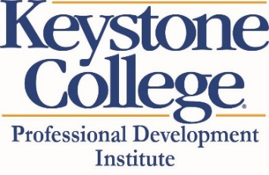
Keystone College Non-Degree Form
I am interested in enrolling in the following Certificate Program:
Date:
Name (Last, First, Middle initial):
Last Four Digits of SS #:
(Note full SS # will be required. This can be provided confidentially)
Gender (male or female):

Address: Street (include Apt. # if applicable):
City, State, Zip Code:
Length of time at this residence:
Phone Number(s):
Email Address(es):
What days of the week/times of day do you have availability for a brief orientation?

Have you ever enrolled at Keystone College? (If yes, dates of enrollment):

Have you ever been dismissed or suspended from an institution of higher education?

Have you ever been convicted of a criminal offense (other than traffic violation)?

When and where did you receive your high school diploma or GED?
(Note that an official copy of HS diploma or GED is required prior to degree status at Keystone College)

Are you a veteran? If yes, please give branch of service and dates you served.

Questions? Contact Keystone College Professional Development Institute
Janet Jones janet.jones@keystone.edu or (570) 945-8621 OR
John Gorel john.gorel@keystone.edu or (570) 536-1925

